6.8 Behavior Diagram

6.8.1: Sequence Diagram

(Generic Sequence)

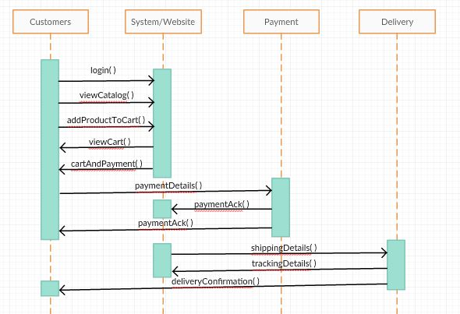

Between Store Manager and System

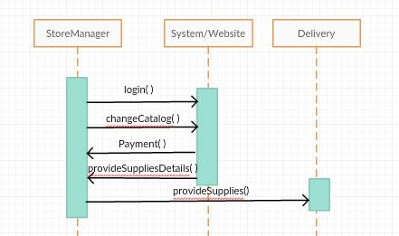

6.8.2: Collaboration Diagram

//Like object oriented diagram

